Team Wattermellon – IcyTower JS Project

Team members: Mario Stoilov, Ivo Petkov, Alexander Drandarov, Kiro Tabakov

Project purpose: a replica of the IcyTower game, made with javascript

Class Diagram: 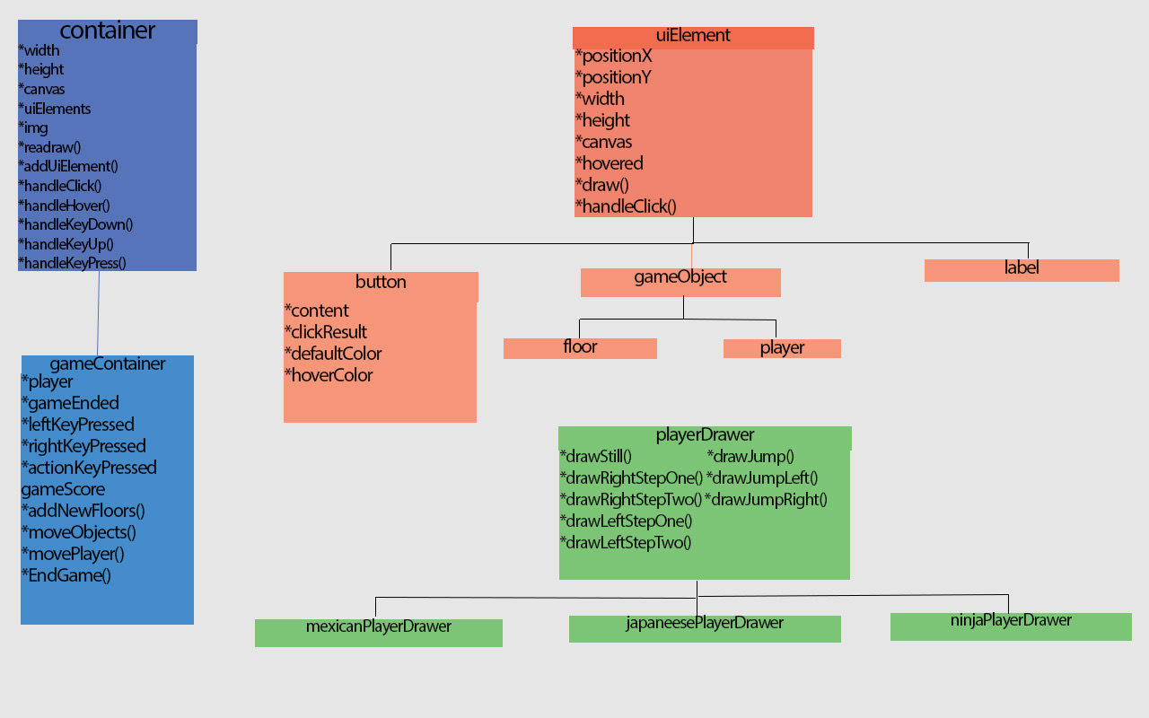

Project repository: <https://code.google.com/p/team-watermellon/>

Game objective: The player should reach the most higher floor possible.

Game rules: Each higher floor gives additional 10 points to the score. Note: when the player “lands” on a lower floor score is reduced with 10 points for each floor.

Settings, which can be adjusted: Player skin, and floor skin – those are kept in local storage for future game sessions to come.

Game info can be shared on facebook, twitter an google+.